Software Requirements specification

for

<Travico>

Prepared by :

Yasmin – al zahraa - ghada

Table of Contents

Table of Contents ii

Revision History ii

1. Introduction 1

1.1 Purpose 1

1.3 Intended Audience and Reading Suggestions 1

1.4 Product Scope 1

1.5 References 1

2. Overall Description 2

2.1 Product Perspective 2

2.2 Product Functions 2

2.3 User Classes and Characteristics 2

2.4 Operating Environment 2

2.5 Design and Implementation Constraints 2

2.6 User Documentation 2

2.7 Assumptions and Dependencies 3

3. External Interface Requirements 3

3.1 User Interfaces 3

3.2 Hardware Interfaces 3

3.3 Software Interfaces 3

3.4 Communications Interfaces 3

4. System Features 4

5. Other Nonfunctional Requirements 4

5.1 Performance Requirements 4

5.2 Safety Requirements 5

5.3 Security Requirements 5

5.4 Software Quality Attributes 5

Appendix B: Analysis Models 5

Revision History

|  |  |  |  |
| --- | --- | --- | --- |
| **Name** | **Date** | **Reason For Changes** | **Version** |
|  |  |  |  |
|  |  |  |  |

# Introduction :

## Purpose

The purpose of the Software Requirements Specification document is to maintain all the functions and the specifications of the Online Bus Ticket Reservation System. Besides, it contains the detailed descriptions of all the requirements specified before.

## Intended Audience and Reading Suggestions

## *The readers of this document are developers, project managers and testers .*

## Product Scope

The scope of the OBTRS is:

1. A person should be able to.

• Login to the system through the first page of the application.

• Change the password after logging into the system .

• Should be able to create a new login for the accessing the reservation facility.

• Able to choose the source and destination .

A mail should be send to the concerned person about the confirmation of the ticket to the specified email address.

The system should automatically show the fare for the corresponding seat and amount of money needs to be pay for selected seats.

## References

[https://www.travcotravel.com/](https://www.travcotravel.com/?fbclid=IwAR3XeT4jmLUCdwZnFh9XQ-6F1R9P44RWMcjnLEWniIRahK__gvn3kpa8MT8)

# Overall Description :

## Product Perspective

Online Bus Ticket Reservation System provides a group of works with interface environments. Also there will be a database which will keep all the records that done by user while visiting the page.

## Product Functions p1

Our system is :

1. A person should be able to.

• Login to the system through the first page of the application.

• Change the password after logging into the system .

• Should be able to create a new login for the accessing the reservation facility.

• Able to choose the source and distination.

1. The admin tool shall handle followings:
2. Shall change the logo
3. Shall add or remove links onto the main bar
4. Shall give options for search tools

d) Shall add, remove or update links on the menu

e) Shall add, remove or update events on the event calendar

f) Shall add or remove medias in the content menu

* .Logout from the system.

## User Classes and Characteristics

The user types that would use the OBTRS are as follows:

**Administrator**: Administrators shall usually do anything on the site, in all pages. Administrator is responsible for updating and the maintenance of the web site content such as adding/removing information about the company, adding/removing links onto the main bar, adding/removing medias in the content menu, adding/removing/updating links on the event calendar and the menu, changing the logo.

**Customer:** Customers are people who shall use OBTRS. To use this service people should have the basic computer using ability. They shall see the buses information which is belong to current time. User can see all general information, FAQ can use search.

**External Users:** External users are people who have not got any user account for the web site. They shall use the general information, FAQ.

## Operating Environment

* distributed database
* client/server system
* Operating system: Windows.
* database: sql+ database
* platform: vb.net/Java/PHP

## Design and Implementation Constraints

<Describe any items or issues that will limit the options available to the developers. These might include: corporate or regulatory policies; hardware limitations (timing requirements, memory requirements); interfaces to other applications; specific technologies, tools, and databases to be used; parallel operations; language requirements; communications protocols; security considerations; design conventions or programming standards (for example, if the customer’s organization will be responsible for maintaining the delivered software).>

## User Documentation

## *User guide template is prepared . User manuals, frequently asked questions and feedback via e-mail will be provided by the system.*

## Assumptions and Dependencies

The user must have the ability to use the internet.

* The user must have connected to the internet to use the system.
* TCP/IP protocol must be installed to communicate through HTTP messages.
* The accuracy of the information of users is the responsibility of all users.

# External Interface Requirements

## User Interfaces

* The user interface is to be designed in a very user friendly manner. The inputs

provided are to be validated at the server side and the results are returned to the client side.

* The user can interact with the system using graphical user interface.

1-Welcome Page

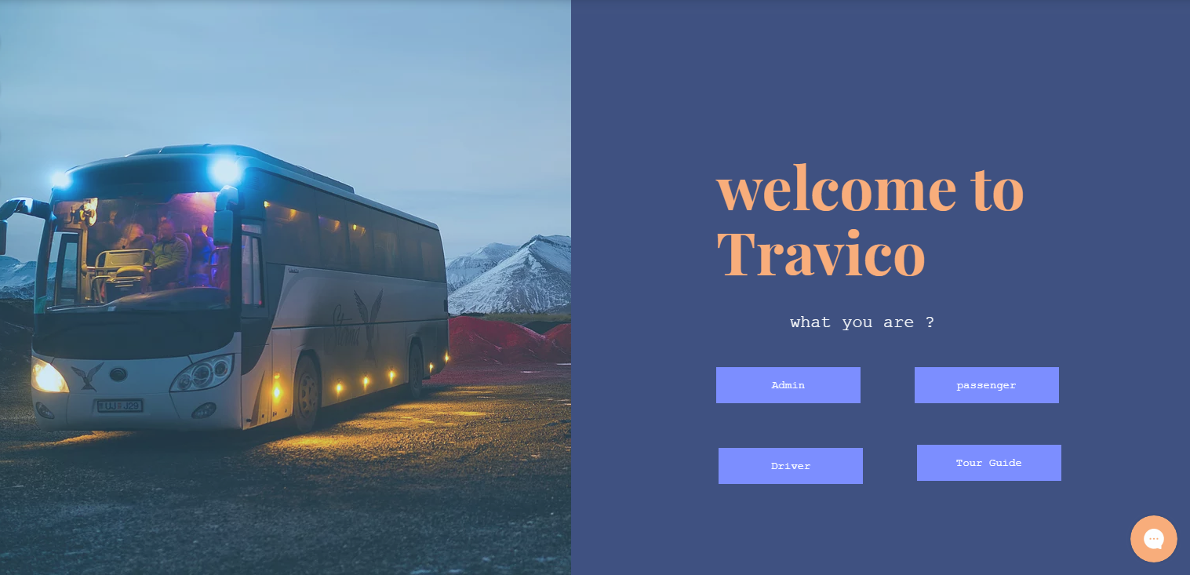

2-Log in (passenger)

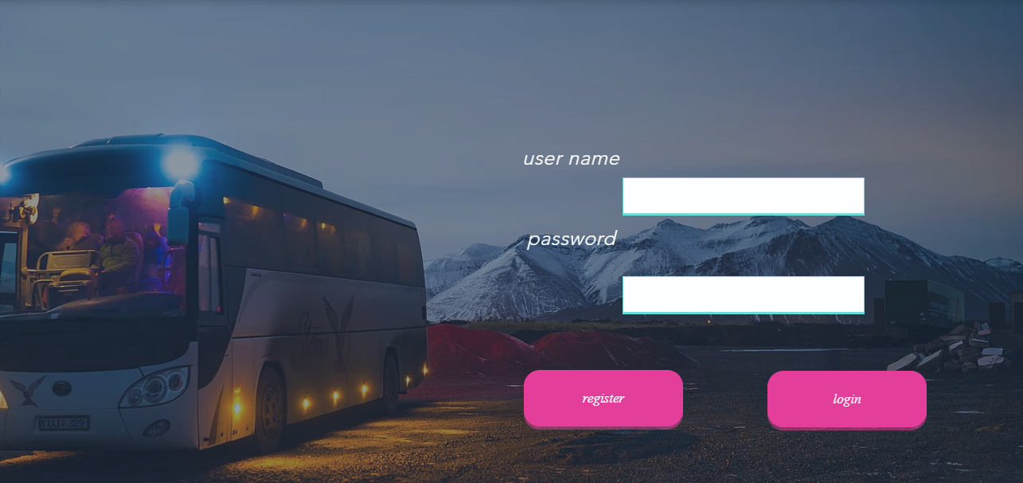

3- Register

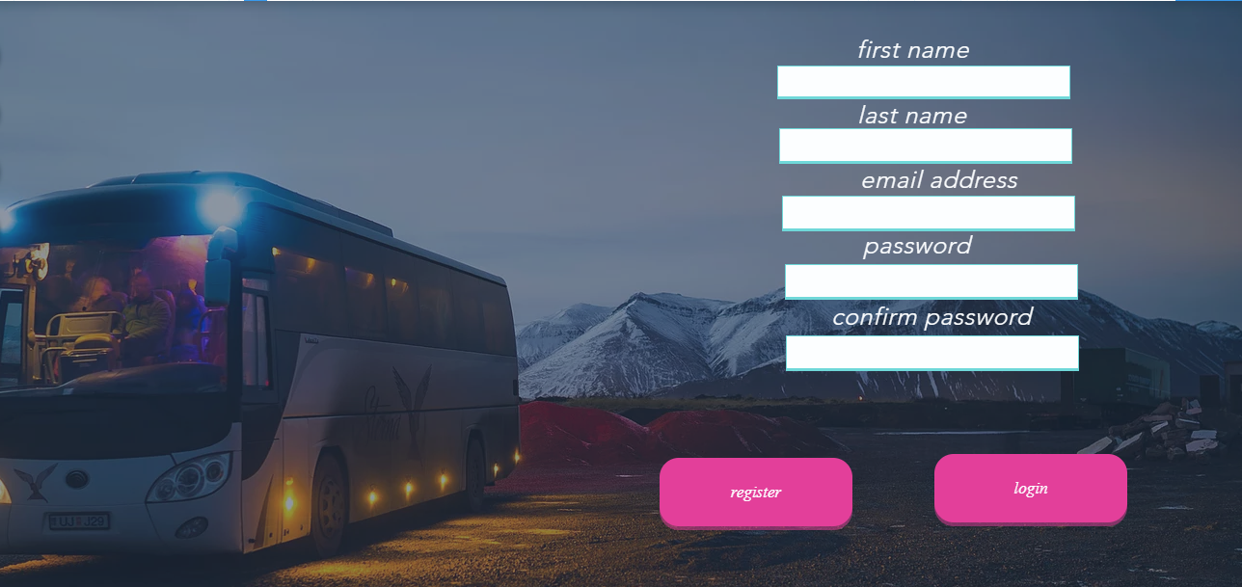

4- Log in (Admin-Driver-Tour guide)

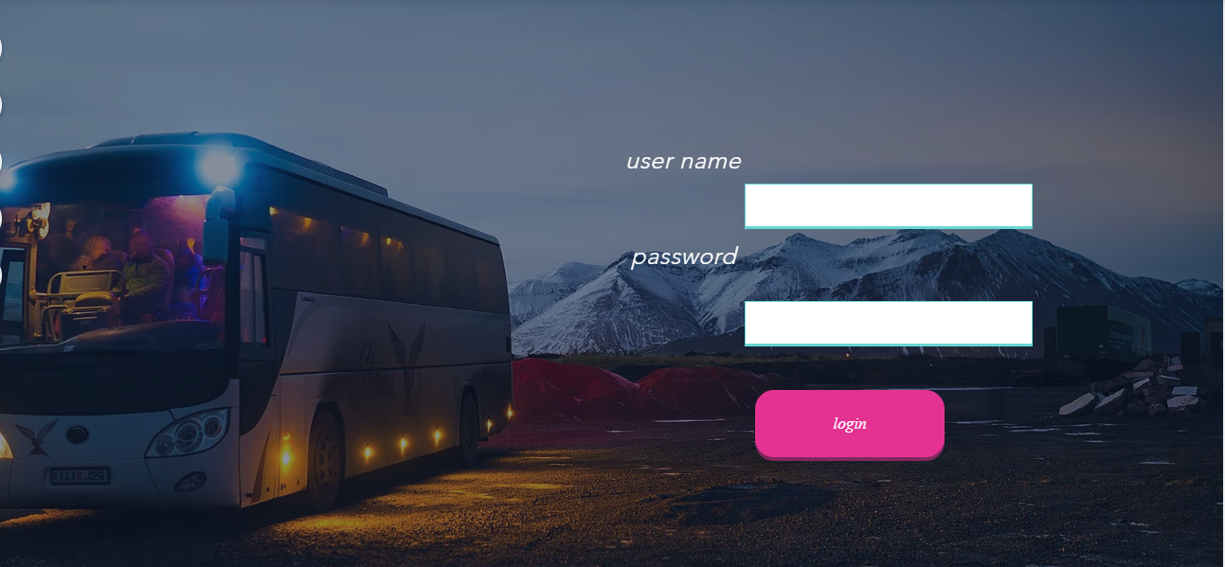

5- User Interface

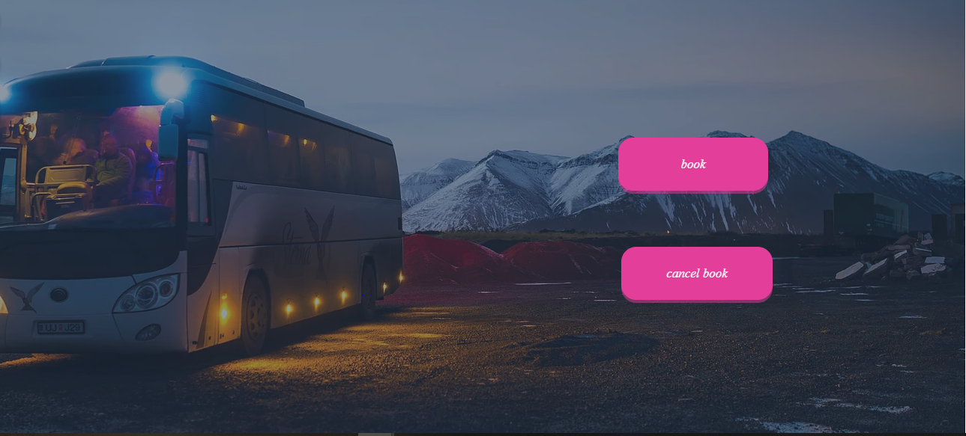

6- Booking

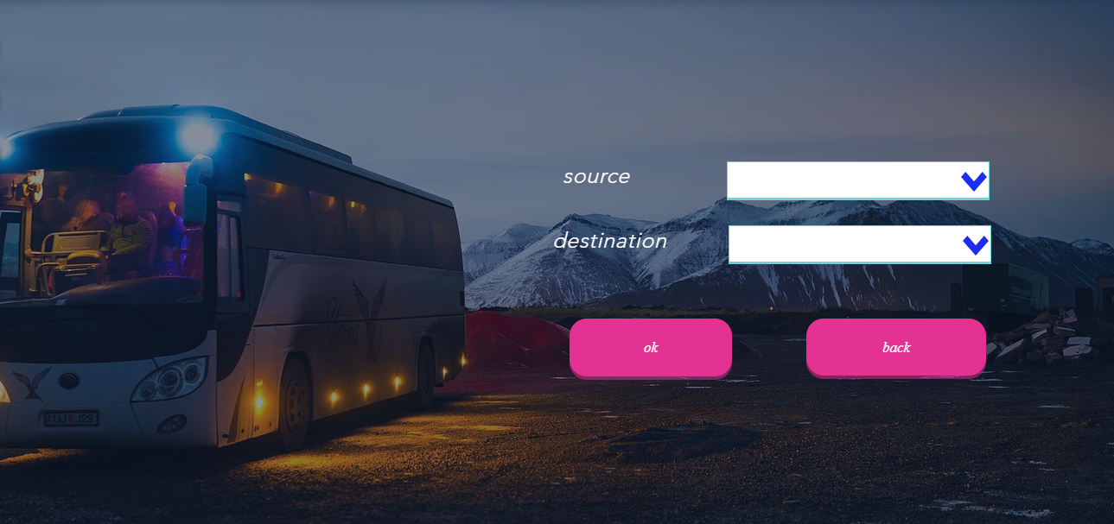

7- Trips

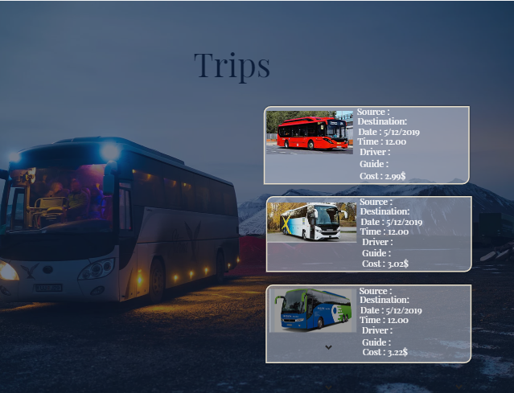

8- Ticket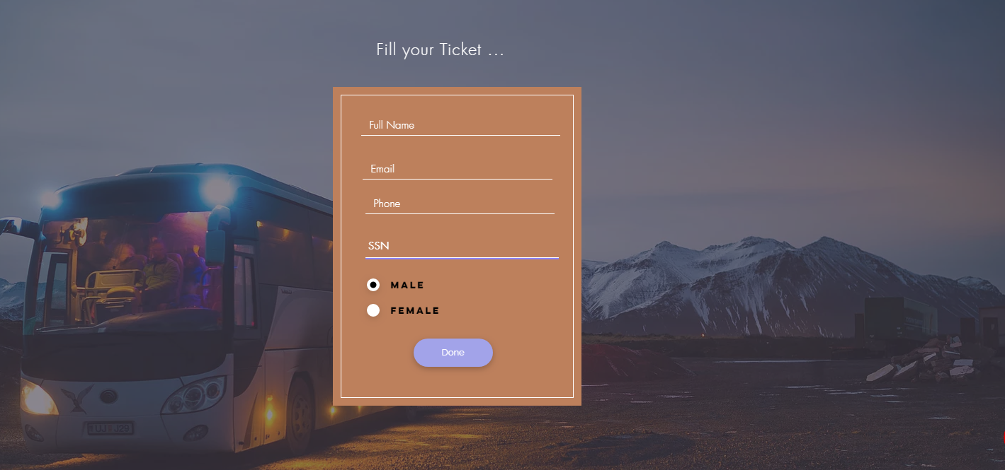

9- Payment

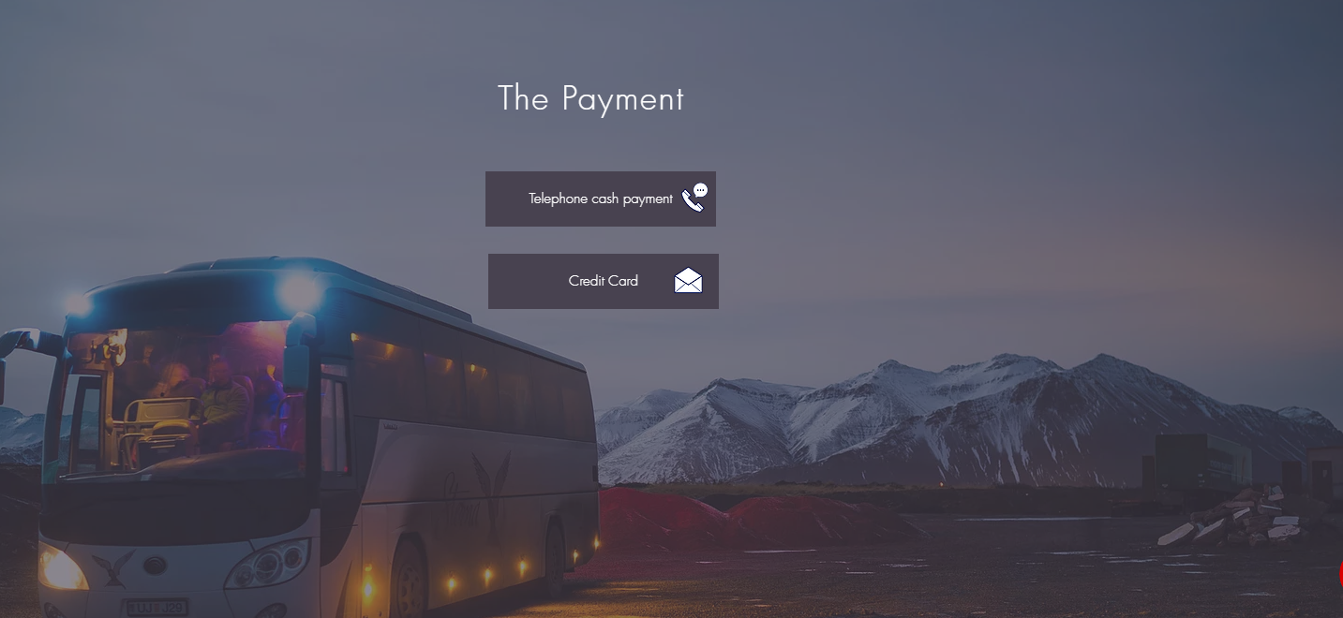

10 – telephone cash payment

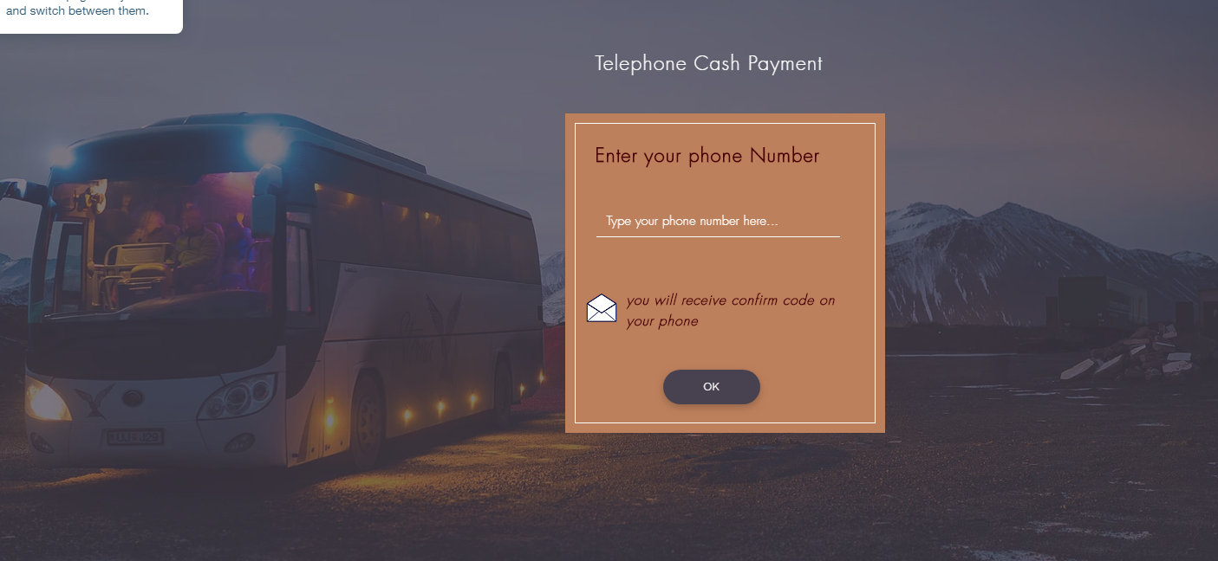

11- confirm code

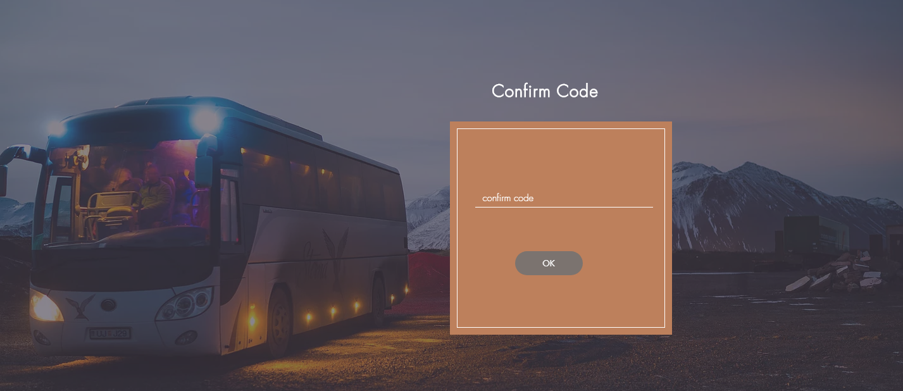

12- credit card payment

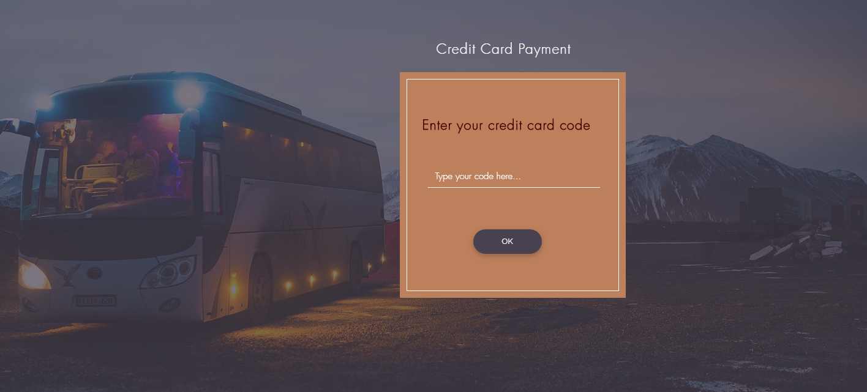

13- successful form



14- Error form



15- Cancellation Form

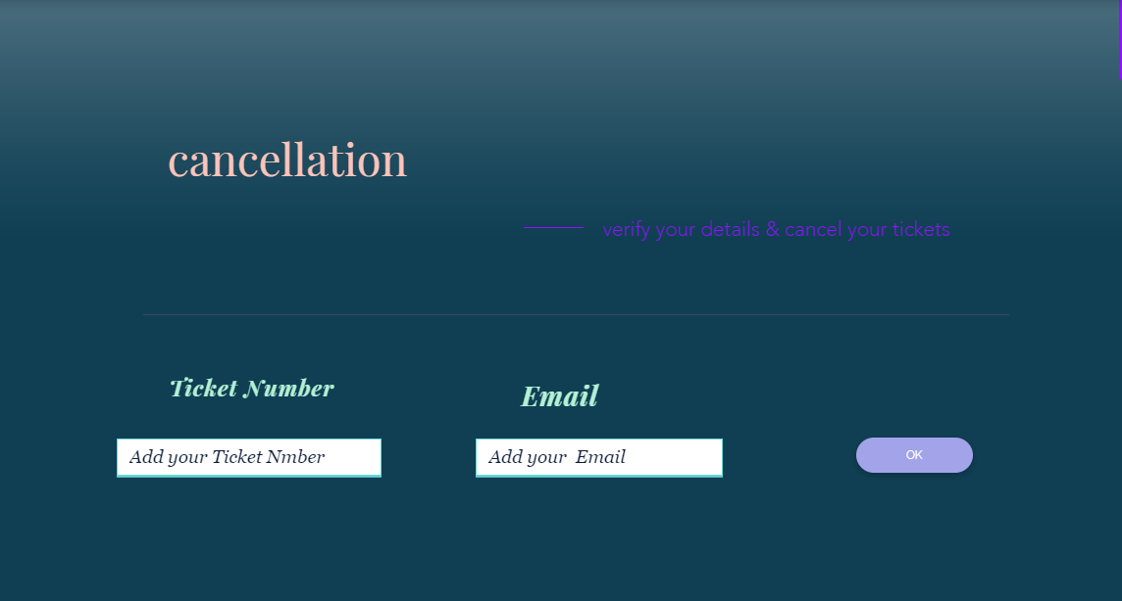

16- successful of cancellation

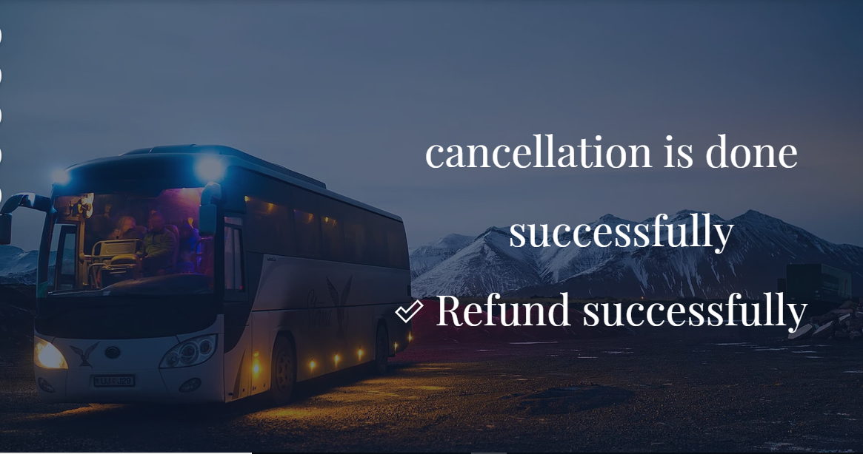

17- Admin menu

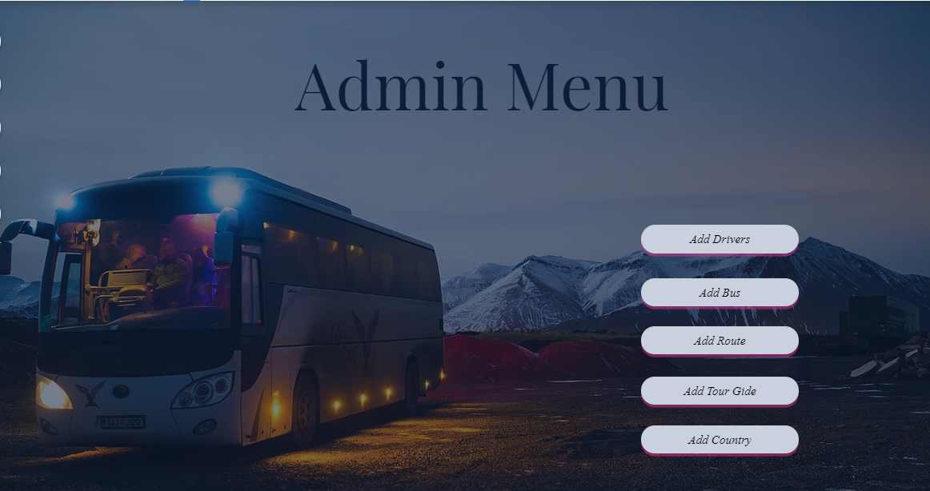

18- Adding Routes

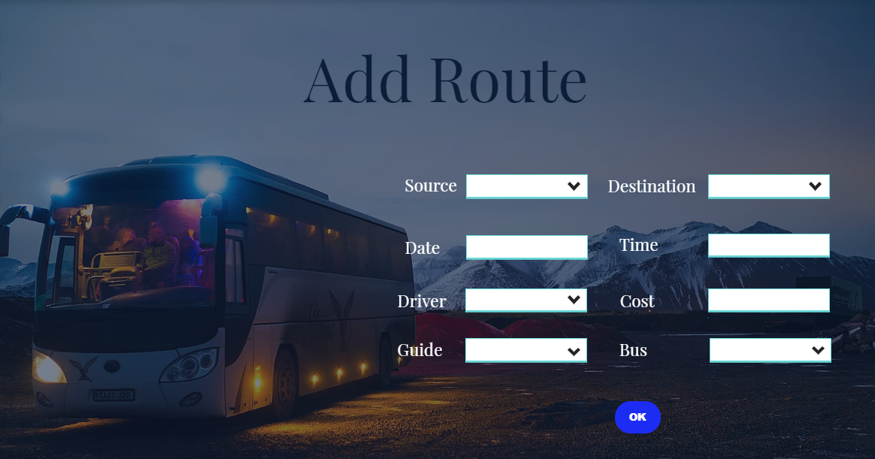

19- Driver Menu

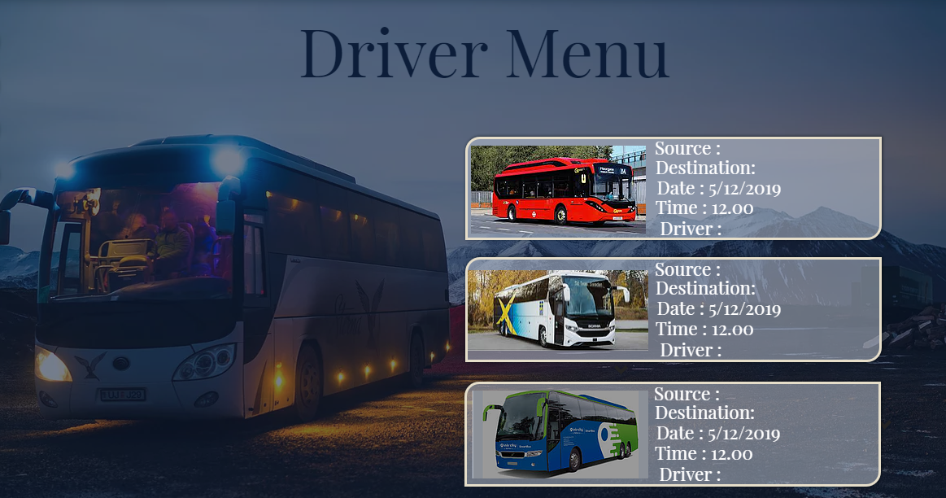

20- Tour Guide Menu

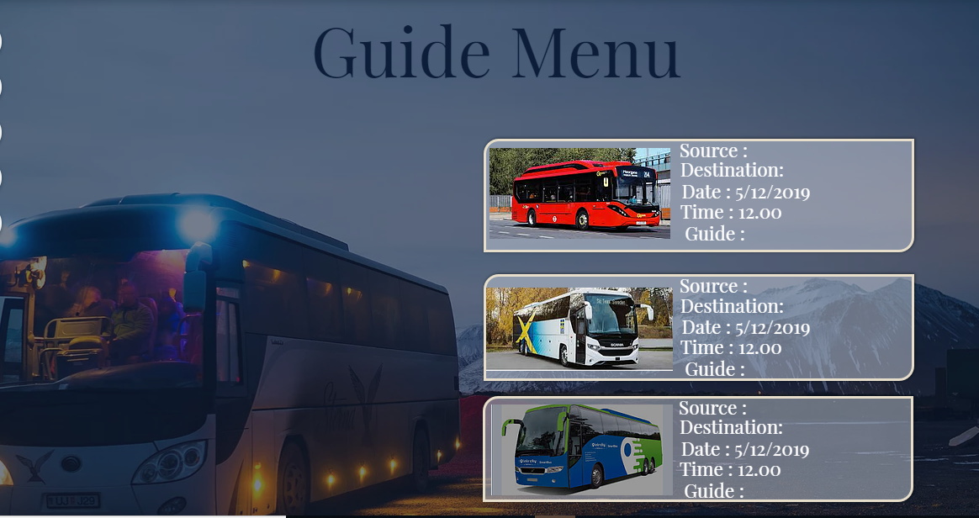

## Hardware Interfaces

* Windows
* Web or mobile browsers will be used to access to the platform.

## Software Interfaces

## On the server side it requires Apache Web server with PHP support and MySQLDBMS. And on the client side, it requires a web browser that supports HTML, JavaScript andCSS.

## Communications Interfaces

This application being a web based one, requires:

• A properly installed and configured network interface device, which can be any of the

following:

o 10/100 Ethernet interface

o Gigabit Ethernet (100/1000) interface

o A WAN/PPPoE interface

o A dial up adapter

o IEEE 802.11 b/g (WiFi) network interface

• It also requires a proper setup communication channel using any of the above for

interaction between server and clients.

• A conflict free Loop back address for the application to reside on the server.

• Server firewall should be configured to allow access from the clients in the Private

Network to its localhost address.

# System Features

* drivers& tour guide registration and management.
* Passenger registration and management.
* Manage passenger bills.
* Booking passenger travelling dates.
* Passenger reports handling

# Other Nonfunctional Requirements

## Performance Requirements

The application shall support multiple users simultaneously. Any number of users can login to this application without any inconvenience.

The system will be available for 7/24 hours.

## Safety Requirements

* The failure of safety critical software functions shall be detected, isolated, and recovered from such that catastrophic and critical hazardous events are prevented from occurring.
* Software shall provide error handling to support safety critical functions.
* Software shall provide fault containment mechanisms to prevent error propagation.
* Software termination shall result in a safe system state.

## Security Requirements

Access to the system is restricted with the help of a login process which requires a

valid username and password

## Software Quality Attributes

## Software quality requirements for this platform are:

## Availability: The system will be 7/24 available. Availability will be reported by web hosting company.

## Usability: System usability will be measured via user surveys.

## Performance: Performance of functions will be tested for timing adequately.

## Reliability: Security tests will be performed sufficiently.

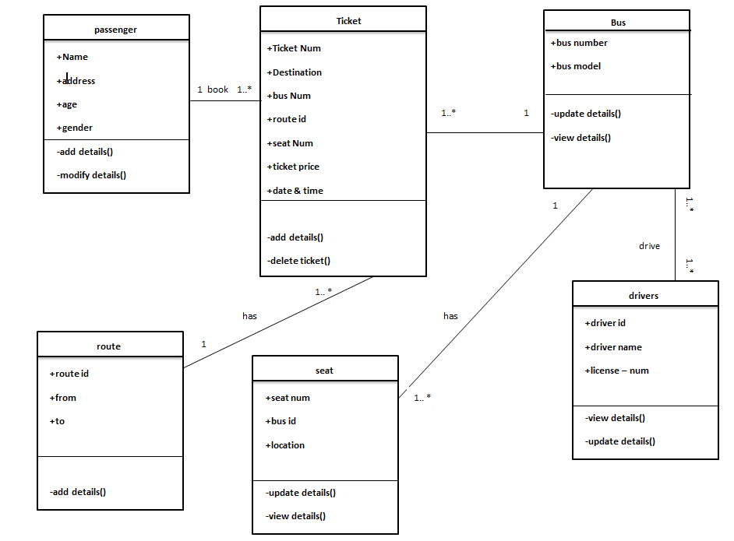Appendix B: Analysis Models